

|  |
| --- |
| **BATCH AND ROLL NO: R6 - 42257** |
| **EXPERIMENT NO.6** |
| **TITLE:** Design a mobile application using image slider to show images. |
| **DATE OF PERFORMANCE** |
| **DATE OF CHECKING** |

**Title:** Design a mobile application using image slider to show images.

# Requirements:

1 Android studio

# Theory:

Web View is to deliver a web application as a part of a client application. The WebView class is an extension of Android's View class that allows to display web pages as a part of activity layout. It does *not* include any features of a fully developed web browser, such as navigation controls or an address bar. All that WebView does, by default, is show a web page.

A common scenario in which using WebView is helpful is when you want to provide information in your app that you might need to update, such as an end-user agreement or a user guide. Within your Android app, you can create an Activity that contains a WebView, then use that to display your document that's hosted online.

Another scenario in which WebView can help is if your app provides data to the user that always requires an Internet connection to retrieve data, such as email. In this case, you might find that it's easier to build a WebView in your Android app that shows a web page with all the user data, rather than performing a network request, then parsing the data and rendering it in an Android layout. Instead, you can design a web page that's tailored for Android devices and then implement a WebView in your Android app that loads the web page.

Steps to follow:

To add a WebView to app, we can either include the <WebView> element in activity layout, or set the entire Activity window as a WebView in onCreate().

Add a WebView in the activity layout

To add a WebView to app in the layout, add the following code to activity's layout XML file:

<WebView android:id="@+id/webview" android:layout_width="match_parent"

android:layout_height="match_parent"

/>

To load a web page in the WebView, use loadUrl(). For example:



**Code:**

**package com.example.myapplication;**

**import androidx.appcompat.app.AppCompatActivity; import android.os.Bundle;**

**import android.webkit.WebSettings; import android.webkit.WebView; import android.webkit.WebViewClient;**

**public class MainActivity extends AppCompatActivity { WebView webView;**

**@Override**

**protected void onCreate(Bundle savedInstanceState) { super.onCreate(savedInstanceState); setContentView(R.layout.activity_main); webView=findViewById(R.id.webview1); webView.setWebViewClient(new WebViewClient()); WebSettings webSettings=webView.getSettings(); webSettings.setJavaScriptEnabled(true); webView.loadUrl("https://pict.edu/");**

**}**

**@Override**

**public void onBackPressed() { if(webView.canGoBack()){**

**webView.goBack();**

**}**

**else{super.onBackPressed();}**

**}**

**}**

# Output:

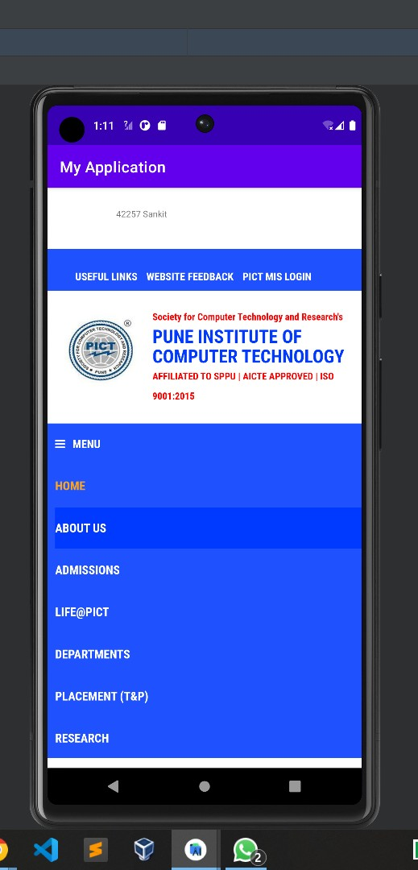



CONCLUSION:

# ……………………………………………………………………………………………

**……………………………………………………………………………………………**

# ……………………………………………………………………………………………